Final Project

**Contents**

1 Initial Data 2

2 Claim determination 4

3 Descriptive statistics 4

4 Hypothesis testing 7

5 Conclusion 7

# Initial Data

Facebook and Apple were picked for the research. Two years historical quotes for each company were downloaded from [www.nasdaq.com](http://www.nasdaq.com). After that, “open” prices of both companies were taken. Based on these two columns Excel spreadsheet was created.

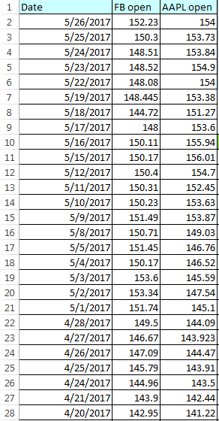

Figure – Initial open prices for FB and AAPL (partly)

The next step was to select 30 random prices for each stock. My approach consisted of two steps:

1. determine random index   
   **RANDBETWEEN( )** function was used
2. select the price according to the index from the previous step  
   **INDEX( )** function was used

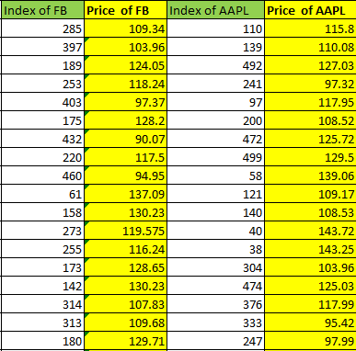

Figure 2 - Prices sampling (partly)

Finally, two samples with 30 values in each formed new CSV document that was used as initial data for the research.

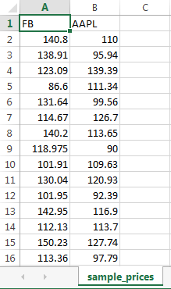

Figure 3 - Research initial data (partly)

# Claim determination

The next step was the claim determination. Claim “means for both populations are equal” was made.

# Descriptive statistics

Since Apple’s stock prices are obviously skewed, median and IQR was used as descriptive statistics for both Facebook and Apple. Calculation results are represented below:

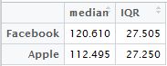

Figure 4 - Descriptive statistics for Facebook and Apple

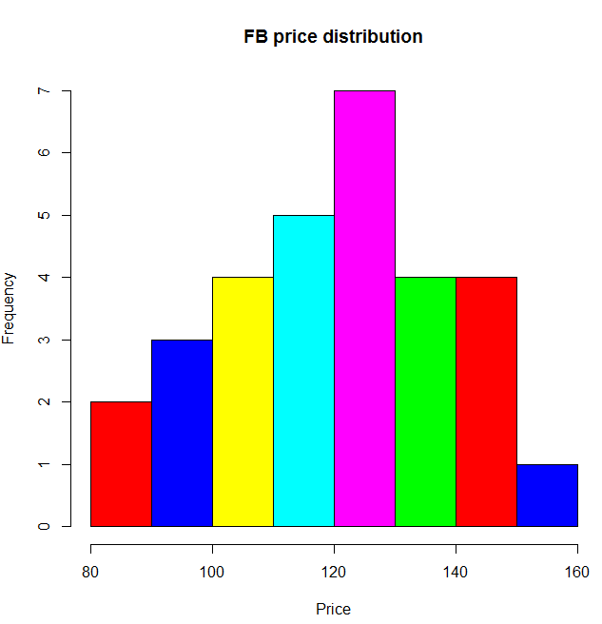

Figure 5 – Facebook sample price distribution

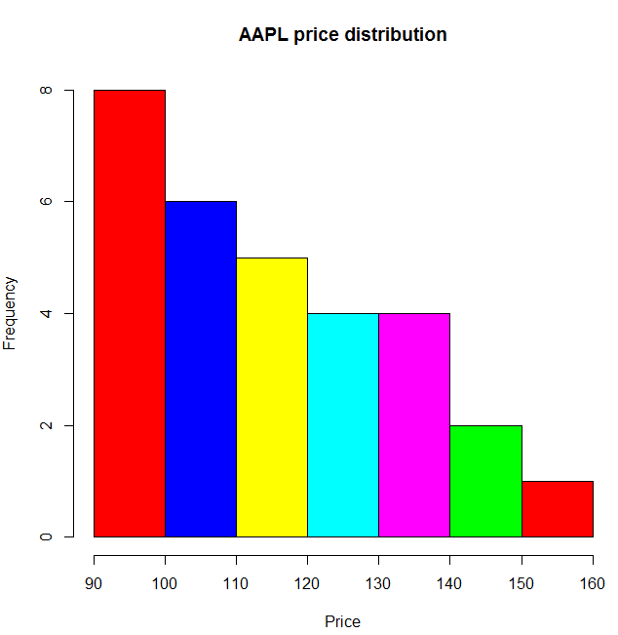

Figure 6 – Apple sample price distribution

Boxplot can be used to find outliers. Results for my samples are represented below.

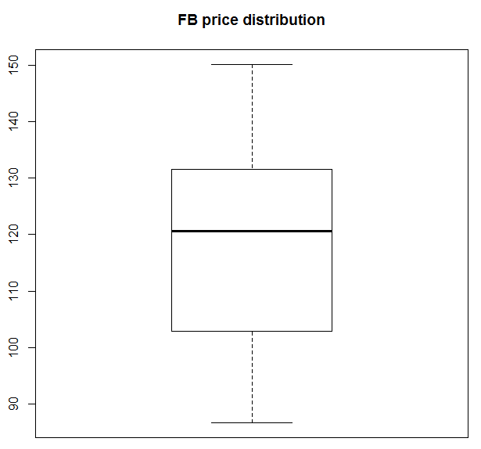

Figure 7 - Test for outliers (Facebook)

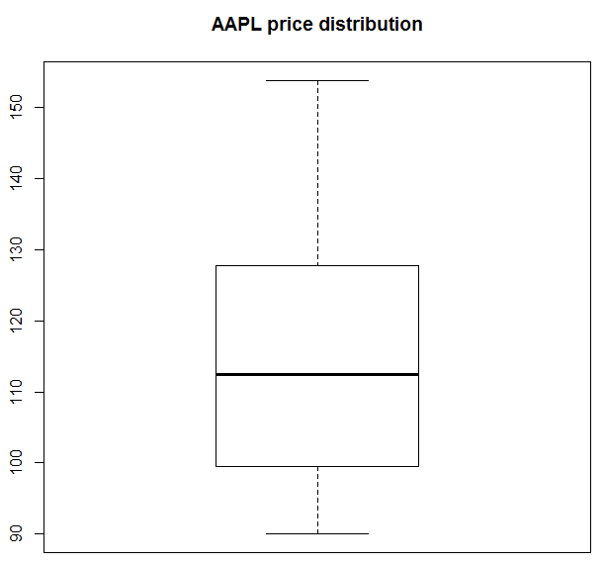

Figure 8 - Test for outliers (Apple)

So, there are no outliers, hence Student’s t-distribution test can be executed.

# Hypothesis testing

We have four restrictions testing hypothesis regarding a population mean:

1. *The samples are obtained using simple random sampling or through a completely randomized experiment with two levels of treatment.*
2. *The samples are independent.*
3. *The populations from which the samples are drawn are normally distributed or the sample sizes are large (n1 >= 30 and n2 >= 30).*
4. *For each sample, the sample size is no more than 5% of the population size.*

In our case all the prerequisites are met.

Since all prerequisites are met, **t.test( )** for difference in 2 population means can be executed. Test results are represented below.



Figure – T-test results

According to the test results, H0 (mean are the same) is not rejected.

# Conclusion

Hypothesis test shows that mean price of Facebook stock is equal to mean price of Apple stock. This result can be explained by a coincidence (compare: Google stock costs $993,27, Microsoft - $69,97 – these stocks are from the same area but have significantly different prices). In general, there is a belief that a lower priced stock on a per-share basis can attract a wider range of buyers. If that increased demand causes the share price to appreciate, then the total market capitalization rises post-split. This does not always happen, however, often depending on the underlying fundamentals of the business. That is the reason for four Apple’s stocks splits.

One more opinion that companies do not want to make their stocks too cheap to save their influence in a price-weighted indexes.